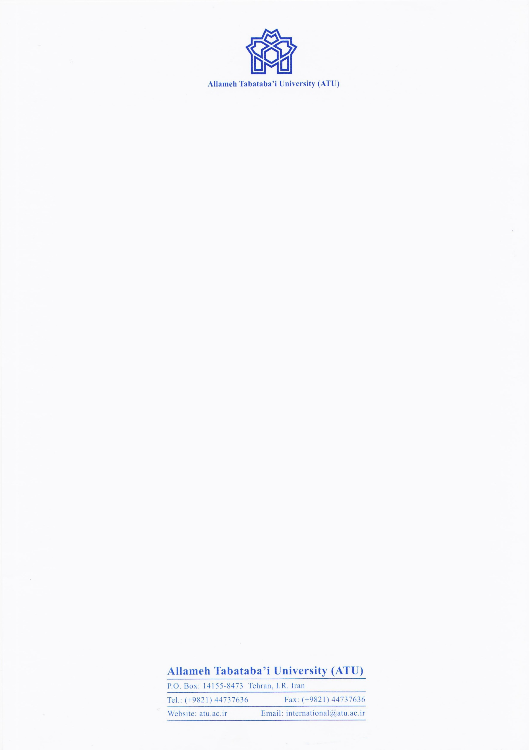

Date:

Ref. No.: 2022-G

Dear Sir/Madam,

This is to certify that Mr/Ms ........., is a .......... student in ................ at Allameh Tabataba’i University (ATU), with Student no. ................ and he/she intends to undergo a virtual exchange stay at Justus Liebig University Giessen.

Yours faithfully,

Dr Mandana Tishehyar,

Director of International Academic Cooperation